PYTHON ASSIGNMENT-2
KEERTHIKA K (2019504033)

CODE:
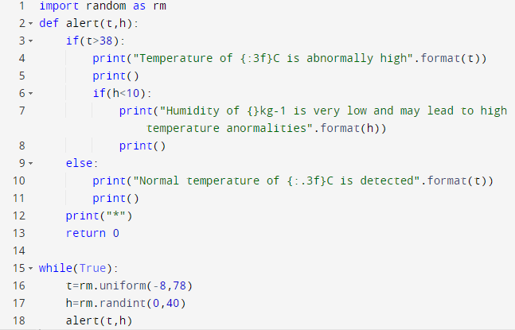

OUTPUT:
